Recommendation Engine
Project Report submitted for the partial fulfilment of grade for the course

Data Structures and Algorithms -3 (25CS2103E)
in

A.Y. 2026-2027

Submitted by
M. Niharika - 2520090021

Team Number: 40
Section: 12

Under the guidance of

Ms. K. Chandusha
Asst. Professor, Computer Science & Information Technology
Department of Computer Science & Information Technology

Hyderabad-500090, Telangana, India.

K L (Deemed to be) University
DEPARTMENT OF COMPUTER SCIENCE AND INFORMATION TECHNOLOGY



DECLARATION

The Mini Project Report entitled “Recommendation Engine” is a record of Bonafide work of M. Niharika – 2520090021 submitted in partial fulfillment for the award of B. Tech in Computer Science and Information Technology to the K L University. The results embodied in this report have not been copied from any other departments/University/Institute.

M. Niharika – 2520090021

K L (Deemed to be) University
DEPARTMENT OF COMPUTER SCIENCE AND INFORMATION TECHNOLOGY
CERTIFICATE

This is to certify that the mini project based report entitled “Recommendation Engine” is a bonafide work done and submitted by M. Niharika – 2520090021 in partial fulfillment of the requirements for the award of the degree of BACHELOR OF TECHNOLOGY in Department of Computer Science and Information Technology, K L (Deemed to be University), during the academic year 2026-2027.

Signature of the Supervisor

Signature of the HOD Signature of the External Examiner

ACKNOWLEDGEMENT

The success of this project would not have been possible without the timely help and guidance rendered by many people. I wish to express my sincere thanks to all those who have assisted me in one way or the other for the completion of my project.

My greatest appreciation goes to my guide, Ms. K. Chandusha, Asst. Professor, Department of Computer Science and Information Technology, which cannot be expressed in words, for her tremendous support, encouragement and guidance for this project.

I express my gratitude to Dr. Khaja Shareef (CSIT), Head of the Department of Computer Science and Information Technology, for providing me with adequate facilities, ways and means by which I was able to complete this project-based Lab.

We thank all the members of teaching and non-teaching staff members, and also who have assisted me directly or indirectly for successful completion of this project. Finally, I sincerely thank my parents, friends and classmates for their kind help and cooperation during my work.

M. Niharika – 2520090021

TABLE OF CONTENTS

S.No. | Contents | Page no.
1. | Abstract | 6
2. | Introduction | 7
3. | Literature survey | 8
4. | Problem Statement and Objectives | 10
5. | Hardware and Software requirements | 11
6. | Implementation | 12
7. | Results & Discussion | 16
8. | Conclusion & Future Scope | 18
9. | References | 19
1.ABSTRACT

The Recommendation Engine is a data-driven system developed to provide personalized recommendations to users based on their preferences, interests, and previous interactions. The main objective of the project is to demonstrate how Data Structures and Algorithms (DSA) can be applied to solve real-world recommendation problems efficiently. The system stores and manages user and item information using suitable data structures such as arrays, linked lists, hash tables, trees, graphs, and priority queues. User-item relationships and interaction patterns are analyzed to determine the relevance of different items. Searching and sorting algorithms are used to efficiently retrieve and rank potential recommendations, while similarity-based techniques can be applied to identify items with common characteristics or user preferences. A priority queue or heap can be used to display the most relevant recommendations at the top. The system focuses on improving search efficiency, ranking accuracy, and response time while handling a growing amount of data. By integrating multiple DSA concepts into a single application, the project demonstrates their practical importance in building efficient, scalable, and user-oriented recommendation systems. The proposed system can be applied to domains such as movies, books, products, music, or online learning resources.
Team Name: Team 40
Team Logo (if any): Not applicable
Team Members:
- M. Niharika, 2520090021
- INTRODUCTION

Today almost every online platform, whether it is a streaming service, an online store, a library portal or an e-learning website, offers thousands or even millions of choices. Faced with so many options, users find it difficult to decide what to watch, read, buy or study next. A recommendation engine addresses this problem of information overload by observing what a user has liked or interacted with in the past and suggesting a small, relevant list of items that the user is likely to enjoy.
The quality of such a system depends not only on the idea behind the recommendation but also on how efficiently the data is stored, searched and ranked. If every request had to scan all users and all items, the response would become very slow as the data grows. This is where Data Structures and Algorithms play a central role: the right structure for each task reduces the time taken for lookup, search, similarity computation and ranking, and makes the system scalable.
The Recommendation Engine developed in this project answers the questions of what, why and how. It is a personalized movie recommender (what) built to show that well-chosen data structures make recommendation fast and practical (why). Item details are kept in hash tables, user-item ratings in a bipartite graph represented with adjacency lists, recently viewed items in a linked list, and item titles in a trie that supports instant prefix search. Similarity between users is measured with cosine similarity, and heaps (priority queues) pick the closest neighbours and the top-N recommendations (how). Although movies are used as the sample domain, the same design applies to books, products, music or online learning resources.
The rest of this report is organised as follows. Section 3 reviews related work, Section 4 states the problem and objectives, Section 5 lists the hardware and software requirements, Section 6 presents the implementation modules, Section 7 discusses the results, Section 8 concludes the report with the future scope, and Section 9 lists the references.
- LITERATURE SURVEY

1. Amazon item-to-item collaborative filtering [1]. Linden, Smith and York described the recommender used on Amazon.com, which matches every purchased or rated item to similar items instead of comparing one customer with all others. The costly item-similarity table is built offline, so the online step depends only on how many items a customer has bought or rated. This allows real-time recommendations over very large catalogues and motivated the scalability focus of our project.
2. MovieLens datasets [2]. The MovieLens collections released by GroupLens Research hold real user ratings of movies and are widely used to test rating prediction and ranking methods. Their user-item rating format is the same sparse structure that our engine stores as a graph of adjacency lists. The real MovieLens data can therefore be loaded into our system later without changing its design.
3. Surprise library [3]. Surprise is a Python library for building and evaluating recommender systems that work on explicit ratings. It provides neighbourhood-based algorithms, matrix factorization methods such as SVD and NMF, similarity measures like cosine and Pearson, and cross-validation tools. Studying it showed how neighbourhood recommenders are structured and compared, which guided our similarity module.
4. Matrix factorization techniques [4]. Koren, Bell and Volinsky explained how matrix factorization models, popularised by the Netflix Prize, represent users and items by hidden factors and give better recommendations than classic nearest-neighbour methods. They also show how implicit feedback, temporal effects and confidence levels can be added. This work indicates the direction in which our similarity-based engine can be extended.
5. A survey paper on recommender systems [5]. This survey introduces the main families of recommenders: content-based, collaborative and hybrid. It discusses item-based collaborative filtering, the Amazon example and the scalability measures needed for large catalogues. It helped us decide which techniques suit a DSA-oriented mini project and how to compare their strengths and weaknesses.
6. Item-item collaborative filtering [6]. This reference explains that item-item filtering was invented at Amazon in 1998 and uses rating distributions per item rather than per user. It is reported to work better when a system has more users than items and to give lower error than user-user filtering. Its ideas are useful for the item-based extension proposed in our future scope.
7. Recommender engines with Surprise (tutorial) [7]. This tutorial builds KNN-based and SVD-based movie recommenders on the small MovieLens dataset using the Surprise package. It shows the sparse user-item matrix, the steps of loading data, training, tuning parameters with grid search and predicting ratings. We used it to understand a typical end-to-end recommender workflow before designing our own version from scratch with core data structures.
8. Recommender systems overview [8]. This general overview covers collaborative filtering, content-based filtering and hybrid approaches, and describes common challenges such as data sparsity and the cold-start problem for new users or items. It helped us define the scope of our project and the limitations that are listed as future work.
- Problem Statement and Objectives
Problem Statement: To build an efficient and scalable recommendation engine that suggests relevant items to users by applying suitable data structures and algorithms to user-item interaction data.
Problem Description: As the numbers of users and items grow, searching, comparing and ranking every item for each request becomes slow, so the system must retrieve and rank relevant recommendations quickly and accurately.
Objectives:
Purpose: The project was initiated to show, through a working application, how core DSA concepts solve the real problem of choosing relevant items from a large collection. The objectives framed from this purpose are:
- To store user, item and rating information efficiently using hash tables, a linked list and a user-item graph.
- To provide fast prefix-based item search using a trie (tree) data structure.
- To measure the similarity between users from their rating patterns using cosine similarity.
- To rank candidate items and select the top-N recommendations using a priority queue (min-heap).
- To keep response time low as the amount of data grows and to verify this with a scalability test.
- To integrate several DSA concepts into a single application that recommends movies to users.
- HARDWARE AND SOFTWARE REQUIREMENTS
Hardware Requirements:
- Processor: Intel Core i3 (or equivalent) or higher
- RAM: 4 GB minimum (8 GB recommended)
- Hard disk: 1 GB of free space
- Standard input/output devices: keyboard, mouse and monitor
Software Requirements:
- Operating system: Windows 10/11, Linux or macOS
- Programming language: Python 3.10 or above
- Libraries: Python standard library only (heapq, collections, math, random, time)
- Editor/IDE: Visual Studio Code, PyCharm or IDLE
- Command Prompt / Terminal to run the program
- IMPLEMENTATION
The engine is written in Python using only the standard library [9][10]. It is divided into four modules, given below.
Module 1: Data Storage Structures (hash tables, graph, linked list)
Item details are kept in a hash table (dictionary). Ratings are stored as a bipartite user-item graph using adjacency lists in both directions, and a singly linked list remembers the most recent items of each user. Lookup and insertion are O(1) on average.
"""Recommendation Engine - DSA-3 project (Modules 1 to 4)."""
import heapq
import math
import random
import time
from collections import defaultdict

class Node:
"""Node of a singly linked list."""
def __init__(self, item_id):
self.item_id = item_id
self.next = None

class RecentlyViewed:
"""Linked list of the last `limit` items a user interacted with."""
def __init__(self, limit=4):
self.head, self.size, self.limit = None, 0, limit

def add(self, item_id):
node = Node(item_id)
node.next = self.head # newest item goes to the head: O(1)
self.head = node
self.size += 1
if self.size > self.limit: # drop the oldest node at the tail
cur = self.head
while cur.next.next:
cur = cur.next
cur.next = None
self.size -= 1

def to_list(self):
out, cur = [], self.head
while cur:
out.append(cur.item_id)
cur = cur.next
return out

class RecommenderStore:
"""Hash tables + bipartite user-item graph (adjacency lists)."""
def __init__(self):
self.items = {} # item_id -> (title, genre)
self.ratings = defaultdict(dict) # user -> {item_id: rating}
self.item_users = defaultdict(dict) # item_id -> {user: rating}
self.recent = {} # user -> RecentlyViewed

def add_item(self, item_id, title, genre):
self.items[item_id] = (title, genre)

def add_rating(self, user, item_id, rating):
self.ratings[user][item_id] = rating
self.item_users[item_id][user] = rating
self.recent.setdefault(user, RecentlyViewed()).add(item_id)
Module 2: Trie-Based Item Search (tree)
Each title is inserted into a prefix tree, and every node remembers the items passing through it, so a prefix search takes time proportional only to the length of the prefix, not to the catalogue size.
class TrieNode:
def __init__(self):
self.children = {}
self.item_ids = []

class TitleTrie:
"""Prefix tree over item titles for fast autocomplete search."""
def __init__(self):
self.root = TrieNode()

def insert(self, title, item_id):
node = self.root
for ch in title.lower():
node = node.children.setdefault(ch, TrieNode())
node.item_ids.append(item_id)

def search_prefix(self, prefix): # O(length of prefix)
node = self.root
for ch in prefix.lower():
if ch not in node.children:
return []
node = node.children[ch]
return node.item_ids
Module 3: Similarity and Neighbour Selection (hashing and min-heap)
Cosine similarity compares two sparse rating dictionaries using only their common items. A min-heap of size k keeps the k most similar users, discarding the weakest neighbour whenever the heap grows beyond k [9].
def cosine_similarity(a, b):
"""Cosine similarity between two sparse rating dictionaries."""
common = set(a) & set(b)
if not common:
return 0.0
dot = sum(a[i] * b[i] for i in common)
norm_a = math.sqrt(sum(v * v for v in a.values()))
norm_b = math.sqrt(sum(v * v for v in b.values()))
return dot / (norm_a * norm_b)

def similar_users(store, user, k=3):
"""Return the k most similar users using a min-heap of size k."""
heap = []
for other, ratings in store.ratings.items():
if other == user:
continue
sim = cosine_similarity(store.ratings[user], ratings)
if sim > 0:
heapq.heappush(heap, (sim, other))
if len(heap) > k:
heapq.heappop(heap) # discard the weakest neighbour
return sorted(heap, reverse=True)
Module 4: Ranking, Recommendation and Driver (priority queue)
Unseen items rated by the nearest neighbours receive a similarity-weighted average score. A min-heap of size N then selects the top-N items. The sample data, a scalability benchmark and the main program are also included here. The full code is supplied as recommender.py.
def recommend(store, user, top_n=3, k=3):
"""Score unseen items from similar users and rank them with a heap."""
scores, weights = defaultdict(float), defaultdict(float)
seen = store.ratings[user]
for sim, other in similar_users(store, user, k):
for item, rating in store.ratings[other].items():
if item not in seen:
scores[item] += sim * rating
weights[item] += sim
heap = [] # min-heap holding the best top_n
for item in scores:
heapq.heappush(heap, (scores[item] / weights[item], item))
if len(heap) > top_n:
heapq.heappop(heap)
ranked = sorted(heap, reverse=True)
return [(item, round(score, 2)) for score, item in ranked]

def load_sample_data(store, trie):
movies = [(1, "Inception", "Sci-Fi"), (2, "Interstellar", "Sci-Fi"),
(3, "The Matrix", "Sci-Fi"), (4, "The Dark Knight", "Action"),
(5, "Inside Out", "Animation"), (6, "Titanic", "Romance"),
(7, "The Notebook", "Romance"), (8, "Avengers", "Action"),
(9, "Toy Story", "Animation"), (10, "Iron Man", "Action")]
data = {"Niharika": {1: 5, 2: 4, 3: 5, 4: 3},
"Asha": {1: 5, 2: 5, 3: 4, 8: 4, 10: 3, 5: 3},
"Ravi": {1: 4, 3: 5, 4: 5, 8: 5, 10: 4},
"Sneha": {5: 5, 6: 4, 7: 5, 9: 5},
"Kiran": {2: 4, 4: 4, 8: 5, 10: 5, 3: 3},
"Meena": {6: 5, 7: 4, 5: 3, 1: 2}}
for item_id, title, genre in movies:
store.add_item(item_id, title, genre)
trie.insert(title, item_id)
for user, rated in data.items():
for item_id, rating in rated.items():
store.add_rating(user, item_id, rating)

def benchmark(users=2000, items=500, per_user=20):
"""Measure recommendation time on a larger random data set."""
random.seed(7)
big = RecommenderStore()
for u in range(users):
for i in random.sample(range(items), per_user):
big.add_rating("u%d" % u, i, random.randint(1, 5))
start = time.perf_counter()
recs = recommend(big, "u0", top_n=5, k=10)
return users, items, (time.perf_counter() - start) * 1000, recs

def main():
store, trie = RecommenderStore(), TitleTrie()
load_sample_data(store, trie)
user = "Niharika"
print("=== Data loaded ===")
print("Items:", len(store.items), "| Users:", len(store.ratings))
names = [store.items[i][0] for i in store.recent[user].to_list()]
print("Recently viewed by %s: %s" % (user, ", ".join(names)))

print("\n=== Search: titles starting with 'the' ===")
for item_id in trie.search_prefix("the"):
title, genre = store.items[item_id]
print(" ", title, "(" + genre + ")")

print("\n=== Users similar to", user, "===")
for sim, other in similar_users(store, user):
print(" %-8s similarity = %.3f" % (other, sim))

print("\n=== Top 3 recommendations for", user, "===")
for rank, (item_id, score) in enumerate(recommend(store, user), 1):
title, genre = store.items[item_id]
print(" %d. %-12s %-8s predicted rating %.2f"
% (rank, title, genre, score))

users, items, ms, recs = benchmark()
print("\n=== Scalability test ===")
print("%d users x %d items -> top-5 computed in %.1f ms"
% (users, items, ms))

if __name__ == "__main__":
main()
- RESULTS & DISCUSSION
The program was executed on the sample data set of 10 movies and 6 users. The outputs of each stage are shown below.
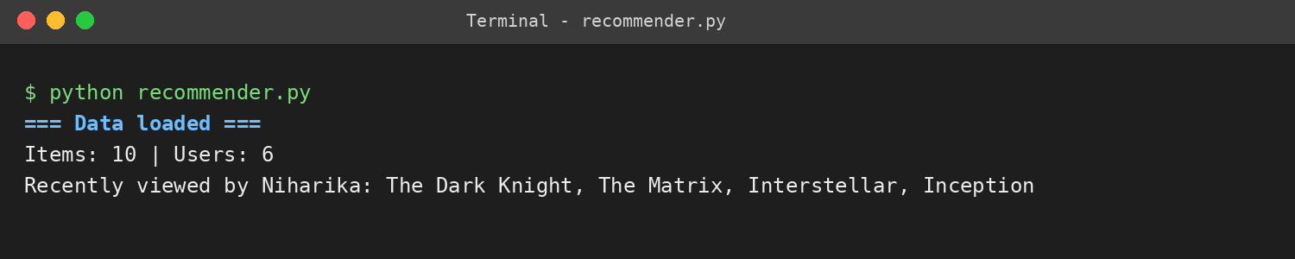
Figure 7.1: Loading of data and recently viewed list
The sample catalogue and ratings are loaded into the hash tables and the graph. The linked list shows the four movies most recently rated by the user, newest first.
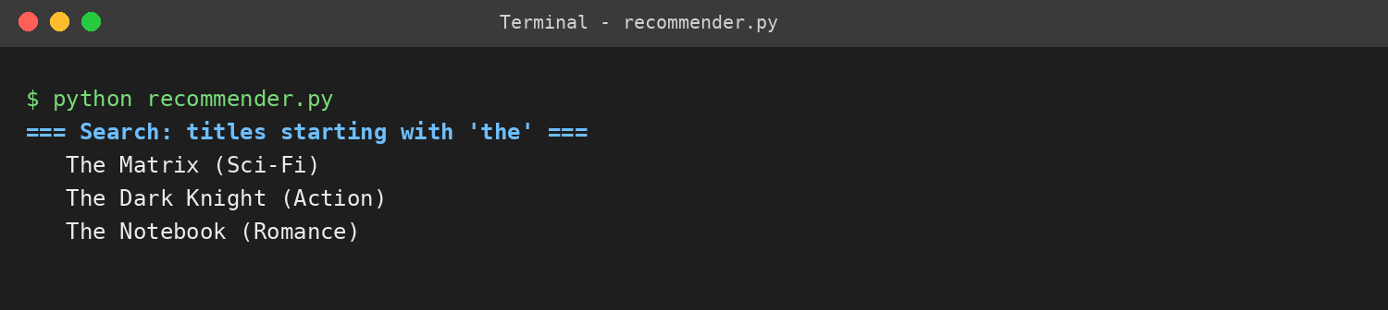
Figure 7.2: Prefix search using the trie
Typing the prefix “the” returns every matching title by walking only three trie nodes, instead of scanning the whole catalogue.
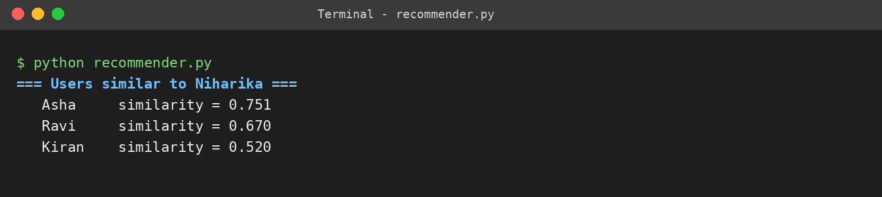
Figure 7.3: Nearest neighbours using cosine similarity
The user is compared with all other users and the min-heap keeps the three closest neighbours: Asha (0.751), Ravi (0.670) and Kiran (0.520).
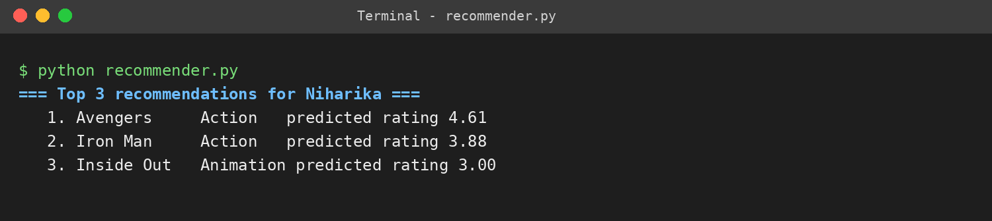
Figure 7.4: Top-3 recommendations
Unseen movies rated by the neighbours are scored by similarity-weighted average and ranked with a min-heap: Avengers (4.61), Iron Man (3.88) and Inside Out (3.00).
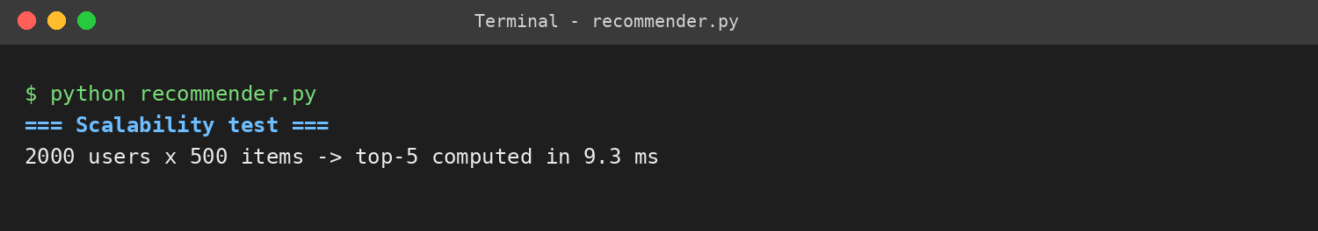
Figure 7.5: Scalability test
On randomly generated data with 2000 users and 500 items, the top-5 recommendations were produced in about 10 ms, so the engine stays responsive as data grows.
Complexity of the main operations
Operation | Data structure | Time complexity
Item lookup by ID | Hash table | O(1) on average
Add to recently viewed list | Linked list | O(1) insert at head (list limited to 4 nodes)
Search titles by prefix | Trie | O(m), m = length of the prefix
Similarity of two users | Hash tables (sparse ratings) | O(r), r = ratings per user
Select k nearest neighbours | Min-heap | O(U log k), U = number of users
Rank top-N recommendations | Min-heap | O(C log N), C = candidate items

Discussion: The results show that every stage of the engine uses the structure that suits it best. Hash tables give constant-time access, the trie removes the need for a full scan during search, and heaps of fixed size avoid sorting all candidates, which lowers the ranking cost from O(n log n) to O(n log k). The recommended movies for the user are consistent with the taste of the nearest neighbours: users who liked science-fiction and action movies receive more action titles. The test on a data set of 2000 users and 500 items (1,000,000 possible user-item pairs) with a response of about 10 ms supports the claim of efficiency. The current limitation is that the engine is user-based, so recommendations for a brand-new user with no ratings (cold start) are not possible.
- CONCLUSION & FUTURE SCOPE
Conclusion
The project aimed to build an efficient recommendation engine using Data Structures and Algorithms, and the objectives were met. User and item data are managed with hash tables, a graph and a linked list; a trie provides fast title search; cosine similarity identifies like-minded users; and min-heaps select the nearest neighbours and the top-N items without sorting everything. The test runs produced sensible recommendations, and the scalability test showed a response time of around 10 ms for 2000 users and 500 items. The project therefore demonstrates that choosing the right data structure for each task is what makes a recommender practical, scalable and user-oriented.
Future Scope
Near term: load the real MovieLens dataset from CSV files, add item-based collaborative filtering and genre-based content filtering, and provide a simple menu-driven interface.
Medium term: build a web interface (for example with Flask) with a database for persistent storage, combine collaborative and content-based methods into a hybrid recommender, and evaluate accuracy with RMSE and Precision@K.
Long term: apply matrix factorization or deep-learning models, update recommendations in real time as new ratings arrive, handle the cold-start problem, and scale the system across distributed servers while protecting user privacy.
- REFERENCES

[1] G. Linden, B. Smith and J. York, “Amazon.com Recommendations: Item-to-Item Collaborative Filtering,” IEEE Internet Computing, vol. 7, no. 1, pp. 76-80, 2003. https://ieeexplore.ieee.org/document/1167344
[2] GroupLens Research, “MovieLens Datasets.” https://grouplens.org/datasets/movielens/
[3] N. Hug, “Surprise: A Python library for recommender systems,” Journal of Open Source Software, 2020. https://joss.theoj.org/papers/10.21105/joss.02174.pdf (project page: https://surpriselib.com)
[4] Y. Koren, R. Bell and C. Volinsky, “Matrix Factorization Techniques for Recommender Systems,” IEEE Computer, vol. 42, no. 8, pp. 30-37, 2009. https://doi.org/10.1109/MC.2009.263
[5] “A Survey Paper on Recommender Systems,” arXiv:1006.5278, 2010. https://arxiv.org/pdf/1006.5278
[6] “Item-item collaborative filtering,” Wikipedia. https://en.wikipedia.org/wiki/Item-item_collaborative_filtering
[7] “Recommender Engines using Python Sklearn-Surprise Package,” Medium. https://medium.com/@rpdatascience/recommender-engines-2c0af4743c17
[8] “Recommender system,” Wikipedia. https://en.wikipedia.org/wiki/Recommender_system
[9] Python Software Foundation, “heapq - Heap queue algorithm.” https://docs.python.org/3/library/heapq.html
[10] Python Software Foundation, “collections - Container datatypes.” https://docs.python.org/3/library/collections.html

